THE CHRYSLER 300 CLUB, INC. MEMBERSHIP APPLICATION/RENEWAL FORM

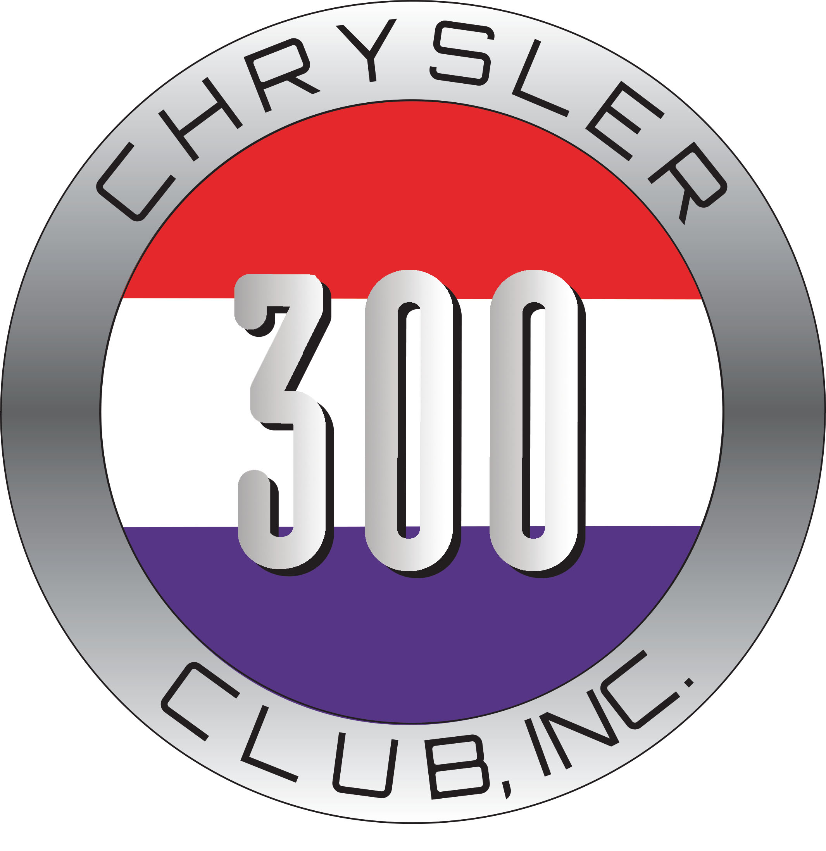 Dues (All in US Funds). Please make checks payable to: Chrysler 300 Club, Inc.
Dues may also be paid by PayPal to toz@pentozzi.com
Addresses: Mail application & check to:
USA: $25/year, $50/27 months Chrysler 300 Club, Inc.
Canadian: US$30/year, US$60/27 months Scott Tozzi, Membership Mgr.
Other Foreign: US$35/year, US$70/27 months 4365 Cheltenham Court
Membership Period: ____ Year(s) Concord, CA 94521-4221

Member Name: ______________________________________ Spouse/Partner: ________________________

Mailing Address: ___________________________________________________________________________

City: _______________________________ State/Province: _____________________ Zip: ________-_______

Home Phone: ____________________ Business Phone: ____________________ Cell: ___________________

Fax: __________________________ E-mail: ____________________________________________________
(Please list the Chrysler 300s you own for our database (list additional Chrysler 300s on the back of this form) :
Car # 1:
Year: ________ Letter: ____ Body Style (coupe, convertible, 4-door): _______________________________

VIN: ______________Hemi Engine S/N: _______________ Original/current color: ________________

Equipment/Accessories/Other Info: _______________________________________________________

Car # 2:
Year: ________ Letter: ____ Body Style (coupe, convertible, 4-door): _______________________________

VIN: ______________Hemi Engine S/N: _______________ Original/current color: ________________

Equipment/Accessories/Other Info: _______________________________________________________

Car # 3:
Year: ________ Letter: ____ Body Style (coupe, convertible, 4-door): _______________________________

VIN: ______________Hemi Engine S/N: _______________ Original/current color: ________________

Equipment/Accessories/Other Info: _______________________________________________________

Car # 4:
Year: ________ Letter: ____ Body Style (coupe, convertible, 4-door): _______________________________

VIN: ______________Hemi Engine S/N: _______________ Original/current color: ________________

Equipment/Accessories/Other Info: _______________________________________________________

